Minutes for School Board Meeting

Thursday 16 March 2023

TIME | Senior Campus Meeting Room 4:30pm SHARP |  | WHOM
4:30pm | 1.0 | Welcome and apologies
 | 1.1 | Opening and welcome:  David Watson, Amanda McNab, James Milne, Chris Smith, Karen Martella, Jonelle McLoughlin, Holly Carter, Isabella Hancock, Iain Browning and Sarah Bible. | Chair
 | 1.2 | Apologies: Lauren Brown and Jesse Richards
 | 1.4 | Confirmation of agenda
4.35pm | 2.0 | Disclosure of interests
 | 2.1 | Identify real, perceived, or potential conflicts of interest | Chair
4:36pm | 3.0 | Minutes of previous meeting and ENDORSE
 | 3.1 | Review of previous meeting minutes – Attached  MOVED: David Watson 2ND: Amanda McNab | Board
4:40pm | 4.0 | Reports
 | 4.1 | FINANCE REPORT – Attached  We are not operational yet, any day now, so this is the information that we have all been working towards for the last six months, based on our student numbers.  Income  Our funding is based on our student numbers of 452, school and student characteristics, target initiatives, operational response allocation (ORA) and locally raised funds. This includes voluntary contributions, our charges and fees, fees from our facility hire, fundraising, donations, sponsorships, includes the P&C and other state/local government revenues (Shire shared library).  Expenditure  Salaries Plan - Staff for the entire year, includes our permanent, staff on a contract. On the report you will see under their jobs, their titles, their FTE.  The new appointments forecast - For example, a Deputy going on leave and their leave has not been processed in the system and we have already hired their replacement, we put that deputy as a negative in planning until it has been processed.  Planning – Casual Days e.g. If a staff member is on sick leave, we do not pay for them, but we pay for their replacement. If we have a staff member going on training or Professional Development (PD), we pay for both, for the person who came in to cover them and the person who is training. We allow for that later, you will see that in the casual days, which is under the casual payments and new appointments. If someone who has fourth term off for long service leave, but we have not brought anybody in or hired anybody yet to cover them, we put that into appointments, just for the planning stage.  Cash Budget  We carried over $105,000 from 2022. We plan on needing $720,000 from salaries, as all our funding comes in as salaries. We are taking $720,000 out of our salary budget, and we balance the budget by taking what we can out of the salary into cash, plus our locally raised funds of $108,000. This is where we get our variance and this changes daily from the bills going through, from credit cards, what comes in and what goes out through the bank account. What I do want to highlight with our Cash Budget. There are two changes this year, two areas where we are spending more money because we're in a position where we can with what we carried over from last year. We would normally spend about $5000 on furniture a year. This year we are really investing in furniture and we are going to be spending about $35,000 in the Senior Campus, it is getting two classrooms of desks and chairs - 32 each (about $18,000 for two classrooms worth of furniture). The Senior Campus will have six classrooms upgraded. The Junior Campus, we are got the Junior, Middle and Senior cluster, last year we supplied new furniture for the students in the Senior Cluster central area and it looks quite good, the kids love it. Junior Cluster did something very similar as well. We are looking at the Middle Cluster for new furniture. Also, AdventureWorks needs $120,000 to run the programme for everybody and so that the kids do not have to pay. I have already allowed for next year's now. That is under Transferred to Reserve you can see $168,000, that's because $120,000 of that is Adventureworks The furniture would be under the Buildings, Property and Equipment - $117,000 we wouldn't normally use that much. There was a request through the Finance Committee for $10,000 for books in classrooms, from the Literacy Committee. The Finance Committee has agreed. Note: Bookfair Cash – donated to the P&C. It is available to purchase books through Scholastic etc. it did not get spent last year so keep this in mind. | Sarah  Bible
 | 4.2 | Student Centred Funding Statement  Per student fundings depends on year groups. e.g.  If we have a year seven student, they are worth about $10,000  Aboriginality we get extra funding for that as well on top per student funding  Disability funding, unfunded and funded.  English as an additional language, Aboriginal English is recognised as a home language and therefore Australian English becomes an additional language or dialect? We gather this information from our enrolment forms.  The educational adjustment, based on NAPLAN results from last year, we get an extra 5% this year and it's based on our NAPLAN results from last year 2022, and any disabilities that are not funded e.g., allergies or asthma  Funding for the Socially Disadvantage - Parents employment and education, it is all based and comes in off the enrolment forms and this is why those questions are asked.  Targeted Initiatives - For the additional education assistant FTE (Full Time Equivalence). Third year - Additional support for the delivery of mental health programmes e.g., SEL  The District High School funding - This would be the second year we have got it. Jamie feels it is not going to continue. We use that entire amount for AdventureWorks, so the students do not have to pay. This funding came to District High Schools through the last bargaining agreement that the state School Teachers Union with The Department to provide $100,000- could also be used for professional learning, support for secondary teachers as well.  The Preschool Reform Agreement - it is just a rename of the National Universal Access to Early Childhood, this amount has not changed but the expansion of the Educational Adjustment – that is an increase.  Operational Response - our Community Librarian with our MOU, with the Shire, we get funding for Erin the Librarian and that is paid by The Department.  Split Site Cash. - The Department gives us the $14,650, and then we have our split site salary allocation, which is really to cover a library officer who works in both the Community Library and for us covers her wages.
 | 4.3 | Salary Plan  We plan on spending nearly $5.6 million.  Cash - close to $900,000 for this year.  Leaving us as at today, a variation of $50,917 which is predominantly in cash.  I think we have only got about $7,500.00 left in salaries as a variant.  But we do have $41,043.00 of cash which changes daily.
 | 4.4 | Cash Budgeting  They are grouped under headings like administration, lease payments, utilities, property equipment. We have about 30 or 40 separate accounts that we manage. The utilities, facilities, maintenance, it is quite high, but that is electricity, water, gas, maintenance and repairs. The Curriculum/Student Services this is all the learning area budgets, classroom budgets and English, History etc. Professional Development (PD) – that is money that we put away for staff, there is always cost or registration fees on PD that the staff go away for.  Transfer to Reserve - is backed up by a plan for future expenditure, we will see that next term. The plan is what we think next year or for the next five years, we know is required. For example - the lawnmower needs replacing, we know that is a $5000 item, we put money away each year to make the purchase.
 | 4.5 | P & C REPORT  We have had two meetings and a successful AGM.  We have new faces, which is exciting.  I feel like it is worth mentioning here that our committee is tired, myself in the president roll I am continuing under the condition that I don't do Secretary as well, so Jesse's moved into that roll. It is also worth noting that Michaela, our Treasurer, has said she doesn’t want to continue, and this is her last year as well as my last year. The Treasurer role is intense because there's wages and super and it's a couple of hours work a week, it is an important role. Joelle, who is our canteen convener has said this will be her last year. We have new people coming through, we are doing everything we can to have continuity, but this committee current is tired.  Michaela and Joelle have been in their current roll for 4 years here, like myself and they also have done years in different roles prior to that, and I think that is quite the commitment. We've even semi lined people up to learn those positions and take-over towards the end of the year, but we will see how that goes.  The AGM went well, we have a committee.  We have had a few funding applications. There is a bit of an issue as we do not have any money yet. We have been approved for Green Team Funding Application to try and support that and we're making an effort towards what's a good fit for P&C Funding because some of the funding applications we receive, we just think maybe are more infrastructure based or just not a good fit for us. Jamie is very good at working with us and seeing how he can help and we're always happy to offer up what we can. One funding application is approved and we're working towards the others, resolving what is needed.  Canteens going well, uniforms going well.  There are a few minor hiccups with some of the ordering of uniforms, but it is not any fault other than supplier issues which has been the way since COVID that it's hard to get uniforms on time and shipments are delayed etcetera, etcetera. There are a few gaps in uniform, but it is happening.  Canteen is going well, I think they have tweaked their roster. Tuesdays were kind of a loss towards last year, but they have tweaked it to just be open for a couple of hours at lunch, which is why Tuesdays are still available. Not recessed, but lunch Wednesday, Thursday, Friday continues to go well.  If you can just have patience with us because the committee is tired, but there's new people and it will be OK.  We are financially viable.  Note:  I have just found out that the sports pavilion is going to have a movie screen and I thought we could have movie nights in there or a Film Festival and that would be a good fundraising opportunity for the school to put on weeknights. It is something we can look into, but it is a long way off. | Karen Martella
 | 5.0 | Business Arising
5.1  Business Plan – overview of progress made around Focus Areas  This is not an official review of progress we have made, but we did want to share regularly.  We have made an awesome start in relation to a number of key focus areas of our new business plan. I am hoping that the leadership team here can tell us very briefly, around their areas that they have been targeting in this first term, initial weeks of 2023, what you are seeing here is just a snippet of the information that we capture amongst ourselves so that we are all aware of the work that's taking place for each other.  Social and Emotional Learning (SEL)  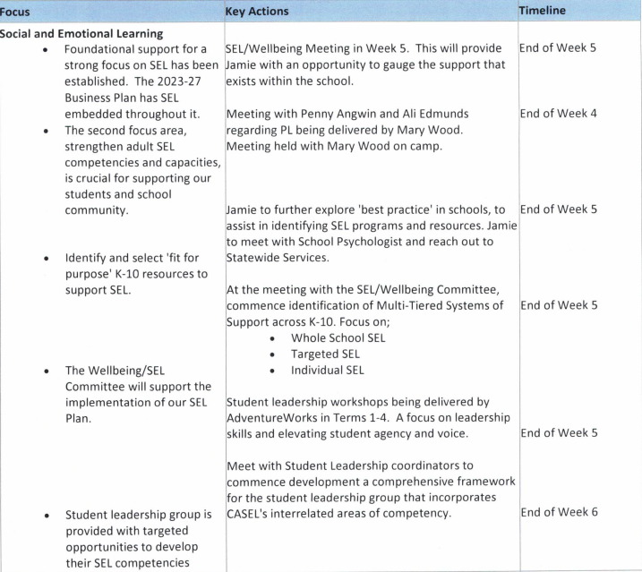  Our plan is around four key areas. The first one around building the foundational support for SEL, and that is about ensuring that we have the ‘’buy in” of our staff to put that whole school focus around SEL. We laid the foundation for that in 2022, it is fair to say and I am confident in saying, that we have an amazing buy in around SEL by our staff for our students and school communities so that foundation support is well and truly there.  The second part of the plan is around building the staff’s understanding capacity around SEL, building their understanding of what SEL is as well as enhancing their own SEL to support them to undertake their classroom or support roles  .  We have Professional Learning (PD) organised for our staff there are four workshops coming up. The first one is next Wednesday and then another two weeks later, that is delivered by our lead school psychologist Alli Edmonds.  Part of my role is to look at ‘’best practise in schools’’, but I have taken a step back as I have been much more around SEL and trying to send the message to staff, it's not about a programme you're putting in place in the school it's about your whole school approach around SEL.  Just to share what I mean by “school wide SEL.” It is about explicit SEL instructions to the students. Focusing on those key competencies of decision making, self-awareness, responsibility etcetera.  - Integrating SEL into academic instructions, ensuring that you are setting goals.  - Collaborative teaching and collaborative structures in place, fostering ownership of learning.  - Co-constructing the curriculum that is delivered to them, so they have a real voice and agency in their curriculum.  - Have high expectations and shared agreements, good routines and procedures and a focus on their own SEL.  - Support of discipline - making sure that our PBS (Positive Behaviour in Schools) is well embedded.  - Positive relationships with staff and students, restorative practises and all the supports in place around our students.  It is more than just a programme we are putting in place it's a whole approach to supporting the development of the students.  Another area of focus is our student leadership group and we have had our student leaders go to their first workshop over in Busselton, which was absolutely outstanding. 170 students, building their leadership skills, their voice in the school, and tapping into help support the school culture. A part of these workshops is a focus on student leaders producing projects and issues that they can help lead and implement within the school. They already have some safe and supportive initiatives as well as sustainability initiatives targeted.  We start developing that into our overall operational plan that really drive our student leaders, not only for the work they do in the school and the community, but also for them personally as well.  We continue working with Adventureworks to refine the workshops and the camps that they deliver. This will no doubt be a learning curve for us all. |  |  | James Milne
Case Management Model  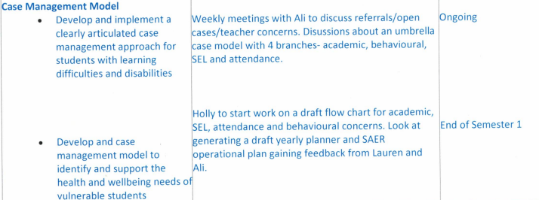  This is to do with students educationally at risk and our disability students, anything under that umbrella. It is very much in the planning at the moment, but I am looking at policies and operational plans from other schools. I am going to develop a plan that is going to help staff understand exactly what everyone's role is. If we have got concerns about students, what interventions we are putting in place, what referrals we can make to support students at school and to support families as well. That is going into a flowchart, and I am working with our School’s Psychologist with this process.  How we can best support students and so they do not fall through the net. Supporting and looking at our response. If a student has been given an individual education plan - What interventions are in place, are they doing MacLit, Bondblocks etc? It is making that process very clear to everyone what we are doing for those students at the different tiers. |  |  | Holly  Carter
Cultural Responsiveness  We have been tasked with our cultural responses and sustainability.  We have surveyed staff on the framework. We have formed a Cultural Inclusivity Committee within the school, they meet in weeks 4 and 8.  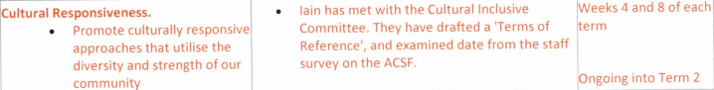  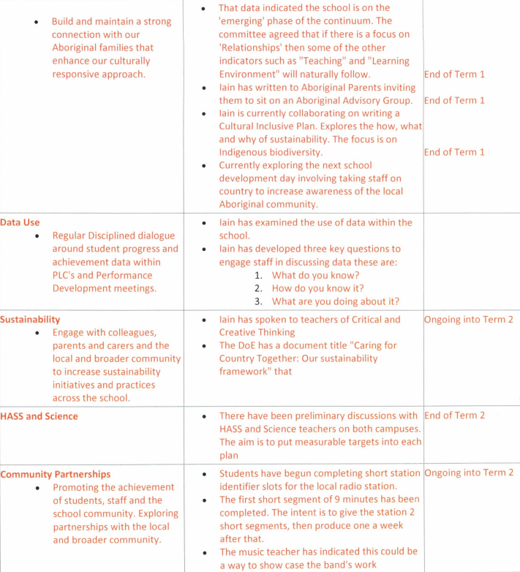  I have also now managed to form a very small Aboriginal Advisory Group. They are meeting with myself, Jamie and Talisha next Wednesday at 4:30pm. I can see that there are gaps in behaviour, achievement and attendance, bearing in mind that is a Federal Initiative. The question has got to be around - what we are doing about that gap? Our next school Development Day, which is on Tuesday the 24th, Jamie has agreed that we will have a ‘On-country Experience’ for staff. I have asked Cameron Khan, who can speak with authority, to talk to staff. The intent right now for the on-country experience is to meet staff down by the waugal. to have a walk/talk about cultural difference of the area, so that staff get a particularly good understanding firstly, about the cultural importance of differences in areas as well as the Aboriginal history of the area. This needs to be a 12-month programme of how we are going to drive Cultural Responsiveness. We are looking for money right now to build two yarning circles on either Campus and I have started to apply for funding. But it is getting quite challenging so if the P&C would like to do fundraise ……? Aboriginal parents find schools a traumatic place, there's intergenerational trauma, some of them will not come to the front door of a school because of this trauma. The idea of the yarning is that it is a neutral area where we can sit in nature and have talks, normal talks we would have with parents. I have drafted a Cultural Responsive Plan around the attendance, achievement and whether people feel welcome as Aboriginal people within our school. It is a very small part of business plan, but it is quite large. The Departments got a Caring for country programme, which is all around sustainability and try to return chunks of departmental land to indigenous plants, and it fits nicely without idea of sustainability, but there is a lot more work to be done around that.  Note:  The Shire has money for Indigenous art.  A yarning circle is compacted gravel area with indigenous plants and a couple of rocks to sit on. A yarning circle off site, would be preferred, and the Shire able to help with the land.  Data Use  I have been asked to look at the use of data and the collecting data. I am not convinced about this actual productive use, right down to the classroom level.  Sustainability  I am aware that the solar panels on the roof are not connected, and they have not been since 2006.  Something to do with the contractor they put them in but something happened and they have never been connected. I have reached out to Jody Hann and to the Shire as this is just a crazy situation. I am told that it is quite widespread throughout the state - a number of schools with solar panels on their roof that aren’t connected.  Can the board decided to write to someone regarding these panels?  Community Partnerships  In case you did not know, every Wednesday at 3:15pm, we have the Donnybrook District High School drivetime radio show for about 10 minutes. The first went out yesterday, it is an ongoing partnership with the local radio station. I have met with the Shire to talk about, whether I can provide statistics and numbers. I have also reached out to Jodie Hann around just trying to form up those partnerships with us. |  |  | Iain  Browning
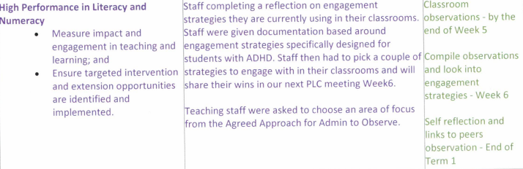  High Performance in Literacy and Numeracy  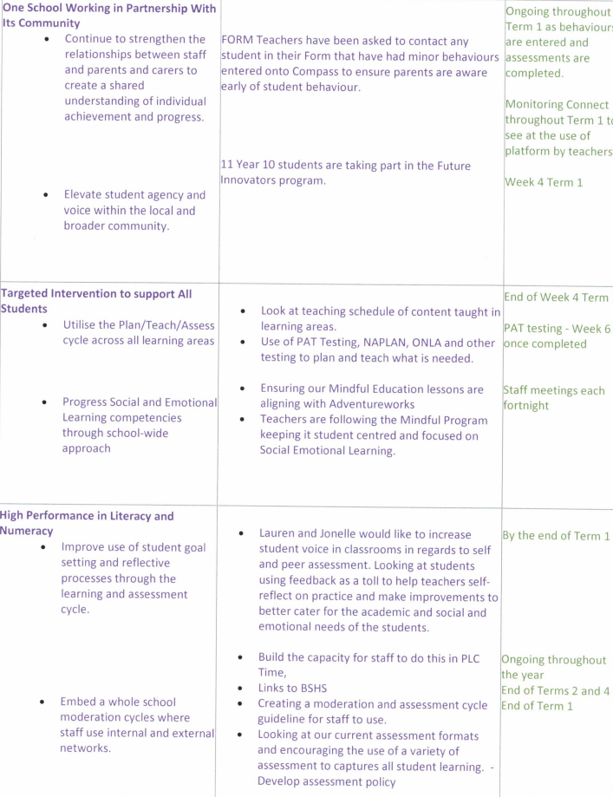  Our focus is the engagement of our students and trying to encourage teachers to use that self-reflection and observation from administration and their own peer observations and increase their engagement strategies in our classrooms for our students. Engaging is an area that we really need to improve on. We need to increase that connection between our staff and our parents because we do know that our parents lose touch as they come up to the Senior Campus. We had a Year 7 Parent meeting that had fifteen parents attend (27 students enrolled in Year 7), it was quite a positive outcome. Our plan is to do more of those meetings with parents. We need more events at the Senior Campus so that we are getting those parents into the school. I had rung every single parent on the Year 7 list, to make sure they knew that it was on and that they we welcome. There was a lot of parents who already had older kids here said, no, we do not need to come, but I feel they do because we don't do the same things as we we're doing five years ago. Through the phone calls, more of the parent attended.  One School Working in Partnership with Its Community  Elevate student agency and working in our local community- we have had an increase of students wanting to go out to work experience. We have had a few local businesses very keen to take on students.  Targeted Interventions to Support All Students  SEL - This overlaps with a lot of information Jamie has talked about. Making sure our Mindful Education (ME) lessons and our AdventureWorks crosses over. We really need to get it into our everyday classes so it's not just happening in that ME lesson or when they're on Adventureworks, we need to start embedding it across the whole campus in every classroom. Parents at the Year 7 meeting were extremely excited AdventureWorks and the SEL, a lot of them saying they wish we had this 20, 30 years ago. The increase student voice also overlaps with what Jamie talked about, having our students in their classrooms co-constructing the curriculum and constructing assessments. If the students have some ownership over their learning and assessments - we will have more engagement and we need to increase this.  High Performance in Literacy and Numeracy  All our staff have a link to Bunbury Senior High and a majority of our teachers are using a programme or similar programmes as Bunbury  Senior High. They've also a connection with a professional that is in in the same learning area as them. |  |  | Jonelle McLoughlin
 | 6.0 | New business
 |  | Year 5/6 Parent Survey  Obviously, we have not captured all the questions, but we wanted to provide a snapshot of this point in time.  Happy to send it all out to the Board when completed.  Parents would be surprised by the connections that DDHS has with other Bunbury Senior High School and Manea College. A representative from those two school will come in to give a talk to students . We also thought it would be handy to have our school psychologists or our leaders on site, especially around the behaviour side of things  An example about if there is a behaviour issue and what happens?  Deputy Example:  An issue occurred with some Senior Campus Students. I talked each student individually about what had occurred, Parents were involved as well. We then had a restorative meeting where the students had to take on responsibility of what behaviour they had used to contribute to the issue. The students then came up, as a group, with a contract of the behaviours that they are willing to follow, which was then signed by them and sent to their parents.  Parents think that the option classes are good, but we do need to get them into classes.  Note:  The Shire is requesting to come and speak to the students and to have a Youth Forum around changes they want to see from a Shire perspective and what they would like to see in the town.  Our Future Innovators (Yr 10’s) can lead that so they feel as though they are getting something out of that workshop that they are going to - perhaps they instigate the meeting with the Shire so their peers see that they have gone off to this workshop and have chosen to engage with the Shire over all of the other local businesses or organisations. | Jonelle  McLoughlin
 | 7.0 | Other Business
 | 8.0 | Next meeting
 |  | 11 May 2023 | Chair
 | 9.0 | Roundtable evaluation
 |  | It may be helpful to finish with the chair requesting a Council member to reflect briefly on how the meeting went or to summarise the decisions and actions resulting from the meeting. | Chair
 |  | Meeting close
 |  | 6:00pm

