Meeting Minutes for School Board Meeting

Thursday 8 December 2022

TIME | Senior Campus Meeting Room 4:30pm SHARP |  | WHOM
4:30pm | 1.0 | Welcome and apologies
 | 1.1 | Opening and welcome:  David Watson, Amanda McNab, James Milne, Amanda Biddlestone, Karen Martella, Jessie Richards, Chris Smith, Lauren Brown, Jonelle McLoughlin, Isabella Hancock and Sarah Bible. | Chair
 | 1.2 | Apologies: Ian Browning
 | 1.4 | Confirmation of agenda
4.35pm | 2.0 | Disclosure of interests
 | 2.1 | Identify real, perceived or potential conflicts of interest | Chair
4:36pm | 3.0 | Minutes of previous meeting and ENDORSE
 | 3.1 | Review of previous meeting minutes – Attached  MOVED: David Watson 2ND: Karen Martella | Board
4:40pm | 4.0 | Reports
 | 4.1 | FINANCE REPORT – Attached  - Figures are up to the end of November  - 90% budget spent  - Learning area have finished spending  - 100% of income is in  - $220,000 salary variance - will take that into 2023  - $50,000 cash variance – minimum  - Finish off contributions and charges - 62% of parents have paid, which is good.  - Without SAS (Secondary Assistance Scheme) we would be 44% of parents paid | Sarah Bible
 | 4.2 | P & C REPORT  - Holiday raffles going well  - Committee gong well  - Finances are sound  - Canteen Junior Campus – worked out that we are also funding breakfast club  - Uniforms going great  - Audio - $7,500.00 for Senior Campus and then Visual - $15,000 the balance will be funded by the school | Karen Martella
 | 5.0 | Business Arising
 |  | Business Plan – Attached  Would like to see the Green Team at the Senior Campus but we must find a way for that to happen as they can’t be left to do the process by themselves. Rachel Seton (Gardener) is keen to get the students involved with the rehabilitation of our bush areas and classes can put their hand up to be involved next year.  Monitoring Spreadsheet - Attached  We have reworked our monitoring of our Business Plan.  The evidence will be added.  It is still in draft form as a timeline is not set yet.  First meeting in Term 2, the Board like to see the evidence in progressing our Business Plan. | James Milne
 | 6.0 | New business
 | 6.1 | 2024 - Year 7 Parent Survey and Forum  Katja Tripp (parent) started a Facebook group around the current Year 5, next year’s Year 6 to generate a discussion around going into High School in 2024 and spoke to Jamie about this.  A survey was thought to be the way to ask these parents what they wanted/needed to know first, then go to a forum so the information that is given is relevant. Jamie is looking at the questions.  Next Year it looks like we will have 26 Year 7 students. We have 8 students from other schools.  At the Senior Campus we are getting more enquires from other school and we have re-enrolled some students that have returned from private schools.  We will keep the Board informed.  We would like the opportunity to highlight what we would like from parents and their commitment to their children’s schooling as it drops off in secondary.  Should the Board be at the forum as parents don’t necessarily know who is on the Board.  Student’s voices will also be involved.  Some students leave because their friendship group leave, so they follow. | James Milne
 | 6.2 | Primary Deputy  Amanda Biddlestone is going to Jurien Bay, and we thank her for her work over the past years.  Interviews have been completed.  The new Deputy is coming from a complex school, Dawson Park Primary School. Her background has a strong as a classroom teacher and instructional coach/mentor to staff, strong SAYER background. Has a lot of experience in supporting students at risk. Has been in the Kimberlie’s coaching and mentoring teacher’s around instructional practise. A lot of experience with outside agencies for Special Needs students.
 | 6.3 | Operational Plans:  Literacy Plan – Attached  Amanda and Alex, as Alex is the Literacy Committee Leader  ALNA for Yr 9 & 10 and target students so they don’t have to sit this test.  Numeracy Plan & Numeracy Operational Plan – Attached  Amanda and Alex, as Alex is the Literacy Committee Leader  Targets  Whole school data, NAPLAN also anecdotal from our PLC’S  Snr Campus –  OLNA for Yr 9 & 10 and target students so they pre-qualify  Jnr Campus –  Numeracy Plan:  Intervention program -Bondblock: MacLit and MiniLit. Looking at the number of students progressing and the number of students testing into the program each year is decreasing.  Looked at prior plans and reflected on the strategies within those plans and relevancy to the classroom.  Feedback from Committees.  We came together see to see we go to for the next set of plans.  Keep focus areas consistent  Four focus areas are:  - Consistency approach  - Curriculum knowledge  - Planning and assessment  - Scaffolding and resourcing  PATR AND PATM  Literacy and Numeracy they refer to PATR and PATM  PATM – comprises of reading and comprehension for Yrs 1 to 10.  It is an online platform form. Can see the gaps in each cohort and can fill in theses gaps or progress student further that need to be progressed further.  WOLF AND WALL – READING ASSESSMENT  WOLF - words read per minute.  WALL are sight words – reading one word at a time.  - Consistency approach sits well with our Agreed approach, and this will be our School  Development Day will begin next year and what at Donnybrook do we believe for and of our students.  Language is consistent from classroom to classroom.  New to this document is supportive documents section to the operational plan to support the teacher that can be refined, added to and developed throughout.  .  - Curriculum knowledge  What is being delivered in the classroom as well as what is around the curriculum to support the students.  - Planning and Assessment – looking at data and what needs to be going over and focus on our moderation and building relationships with others school.  - Scaffolding and Resourcing  How and what resources we need to achieve that outcome. Professional Learning – that that information is shared with everyone. Making sure that resources are available to the students, on hand. The timeline and evidence still need to be refined too but a nice starting point to what is happening in the classroom.  Targets are draft targets. Both plans will have a timeline.
 | 6.4 | Mindful Education  Middle of Term 2 the Senior Campus have been teaching Mindful Education.  It has taken time for the students to feel comfortable sitting in a circle.  The students have written their response to some questions asked e.g.  - What did you like the best?  A) Sitting in a circle.  Q) Did you think you got to know your teacher better?  A) above 50%  - Is there anything we can do better?  - Year 9 boys didn’t like not doing their options or sport (mainly Yr 9 Boys).  - How has it helped me this year?  - Helped me speak to my parents more.  Next year the students will be doing more age-appropriate content and Jonelle is working on plans for this now.  Surveyed students on next year –  Year 7, 9 10 are interested in talking about depression, anxiety, how to cope with stress. Year 8 careers and how do buy a house and do my taxes. Year 10 – gender, femininity and masculinity.  Jonelle feels that we have made a huge difference, but we have a long way to go.  Some students what the check in/check out at the beginning and end of each session.  Teacher Responses  Q) What did they like the most?  A) Nice not having to “teach” any curriculum and just being able to talk to the students.  Teachers will be staying the same gender as they have this year and as AdventureWorks does.
 | 7.0 | Other Business
Chris Smith position is no longer a part of the Shire but is now a parent representative.
Moved; David Watson 2nd: Karen Martella
 | 8.0 | Next meeting
 |  | Week 5 – 2 March 2023
 | 9.0 | Roundtable evaluation
 |  | It may be helpful to finish with the chair requesting a Council member to reflect briefly on how the meeting went or to summarise the decisions and actions resulting from the meeting. | Chair
 | 10.0 | Meeting close
 |  | 6:45pm | Chair

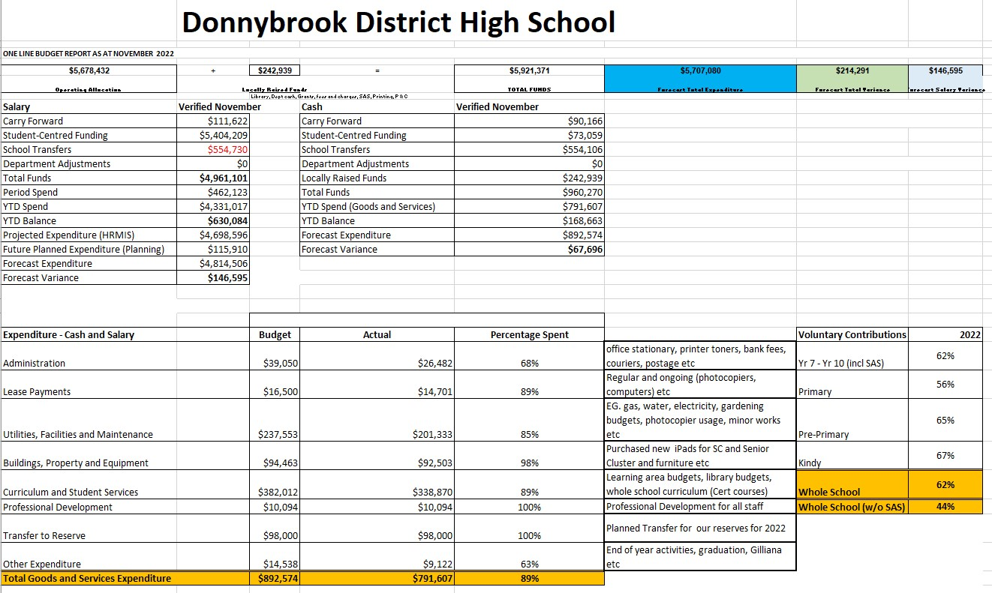

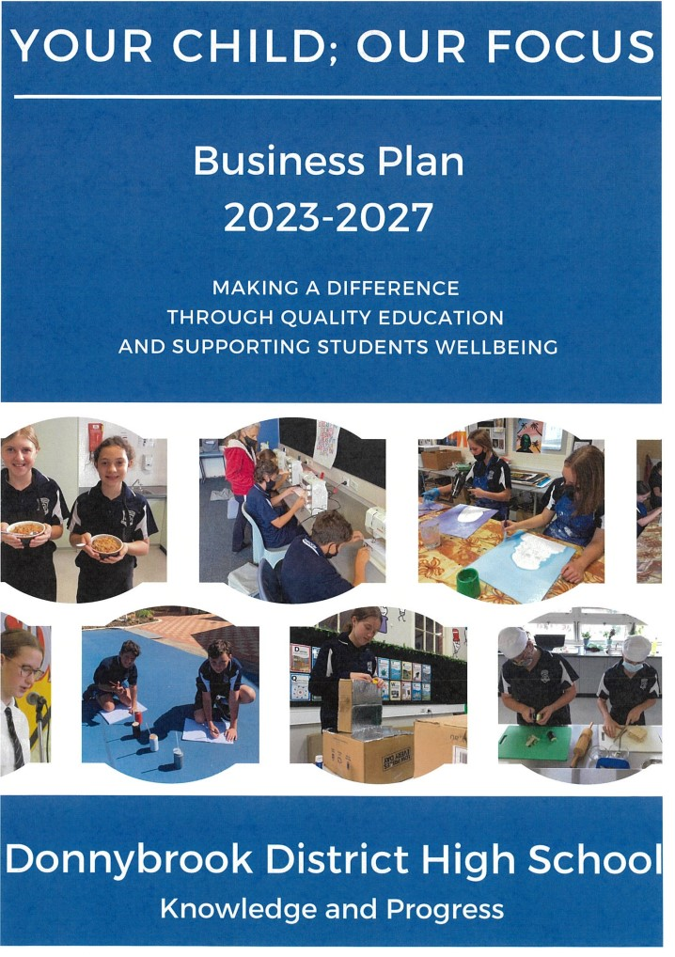

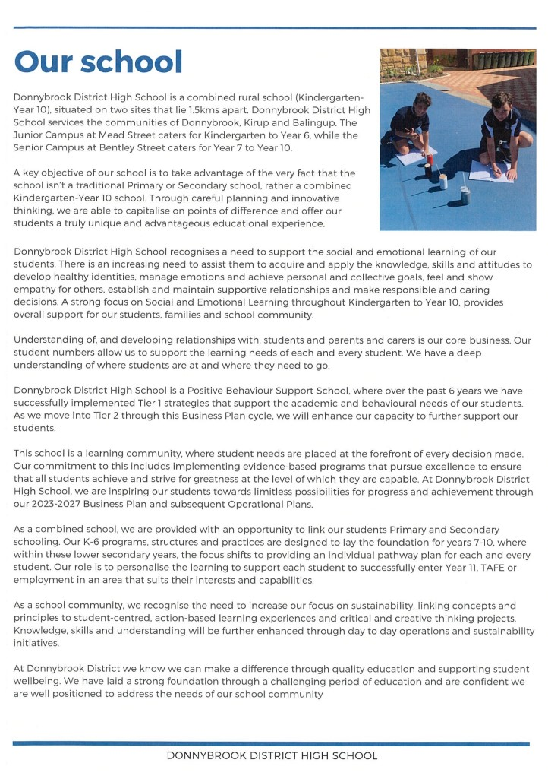

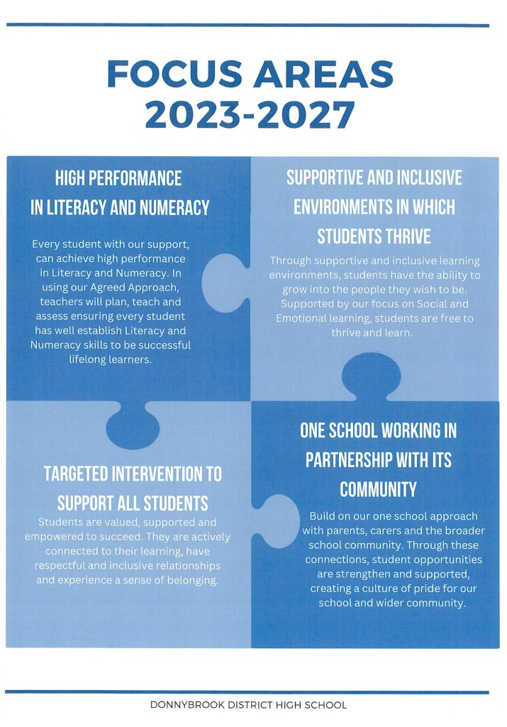

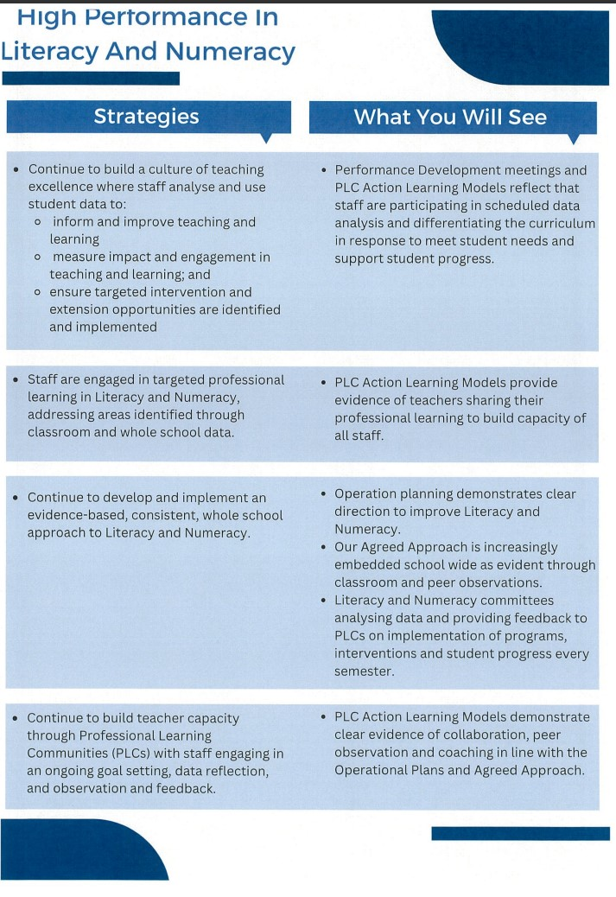

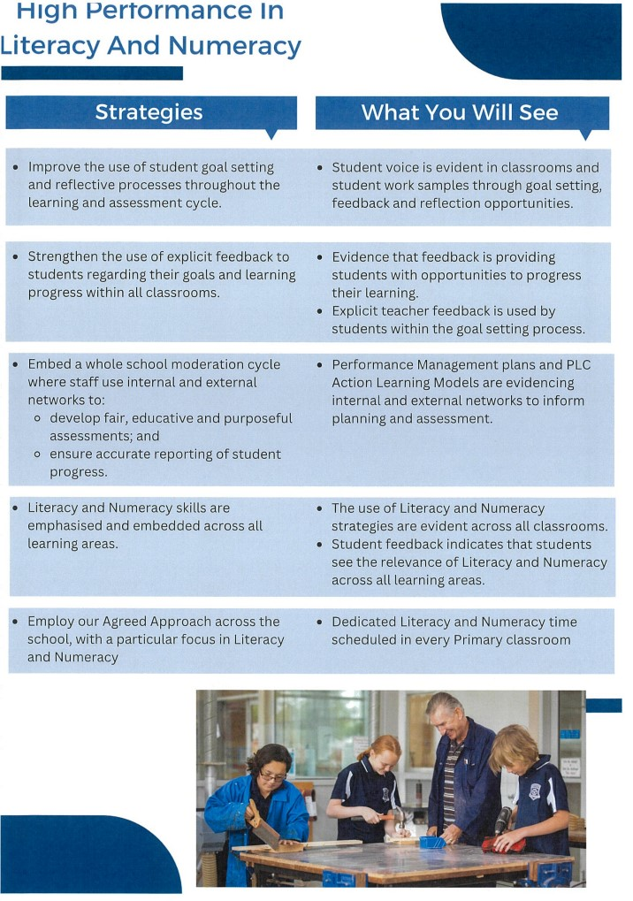

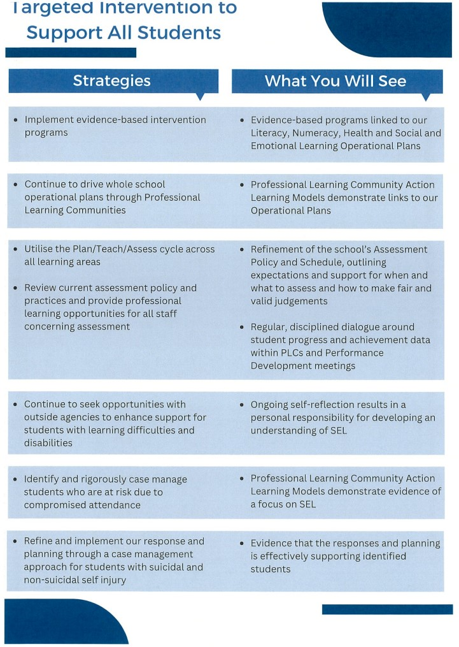

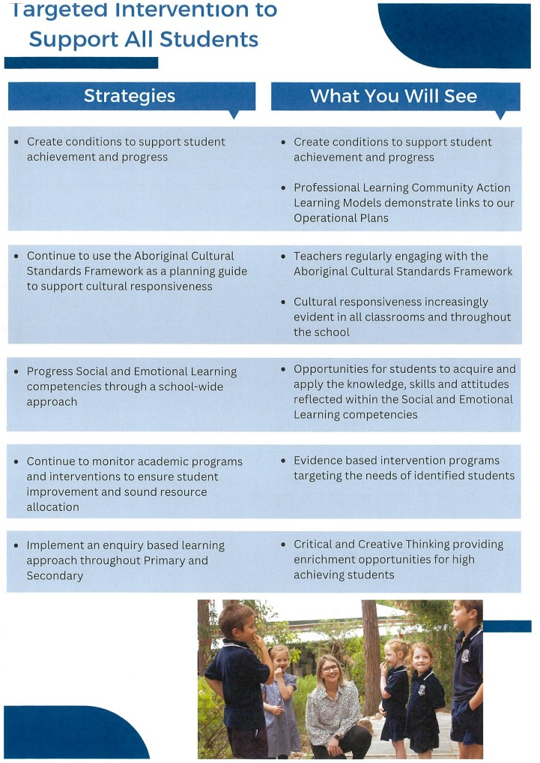

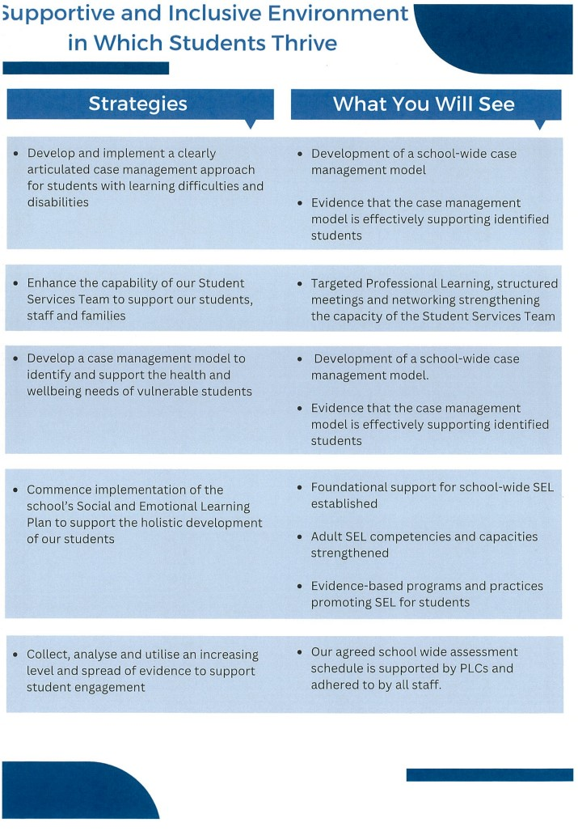

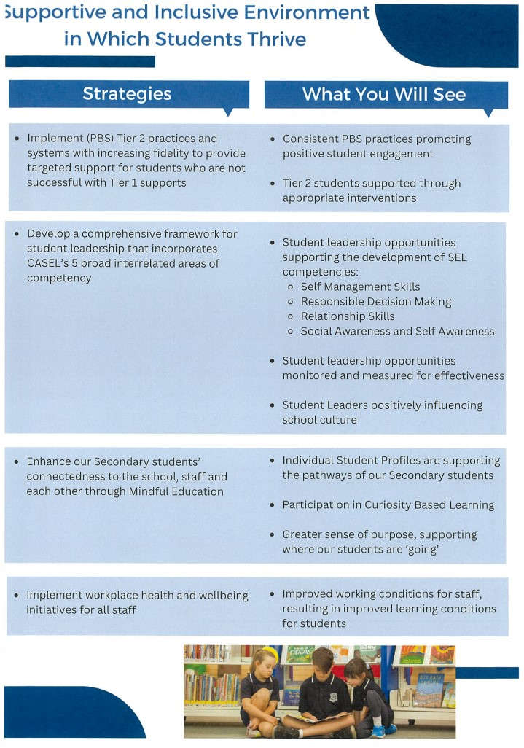

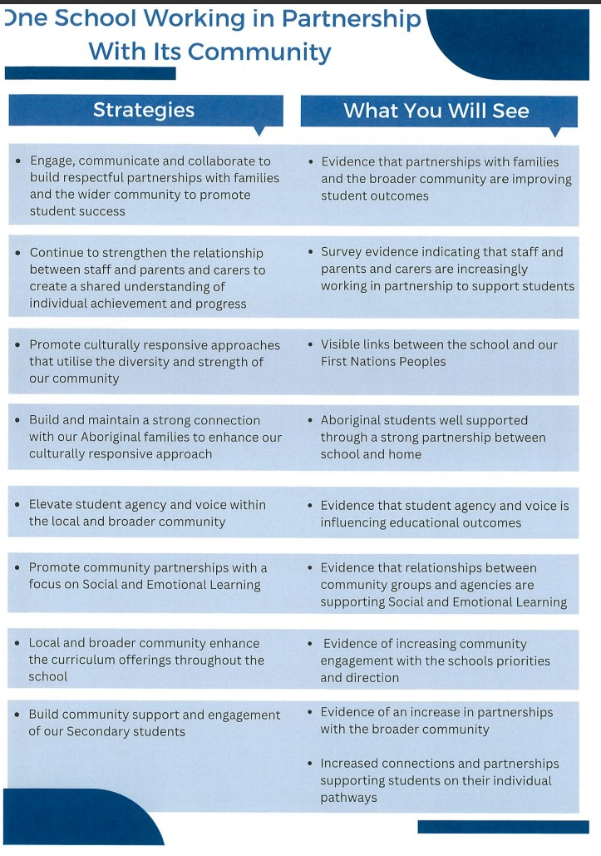

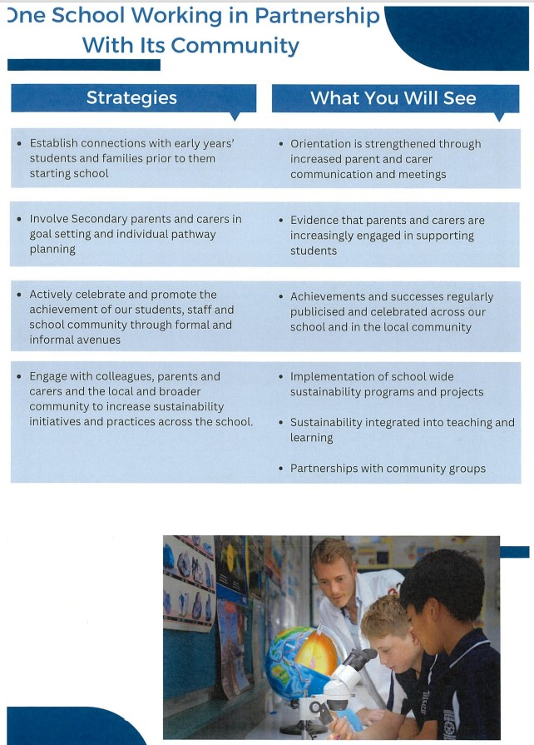

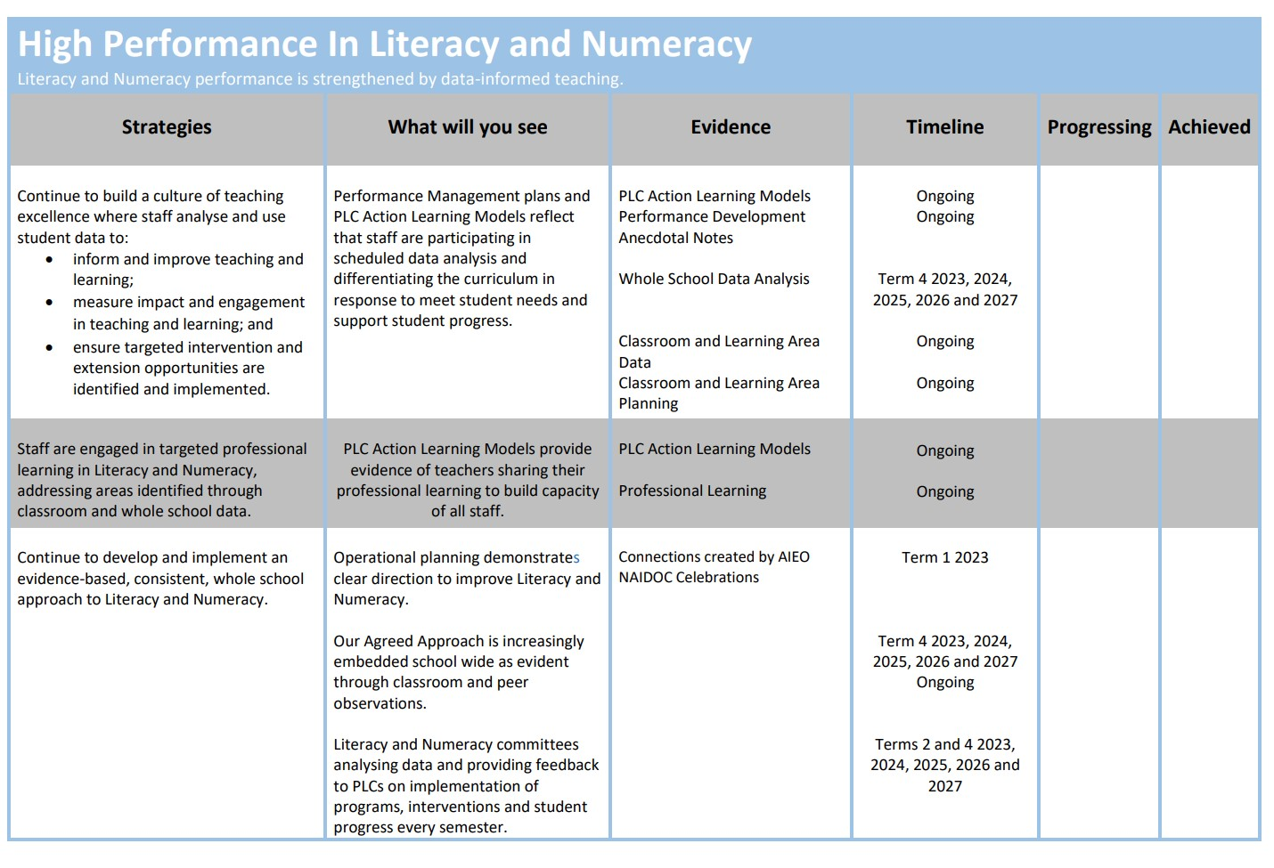

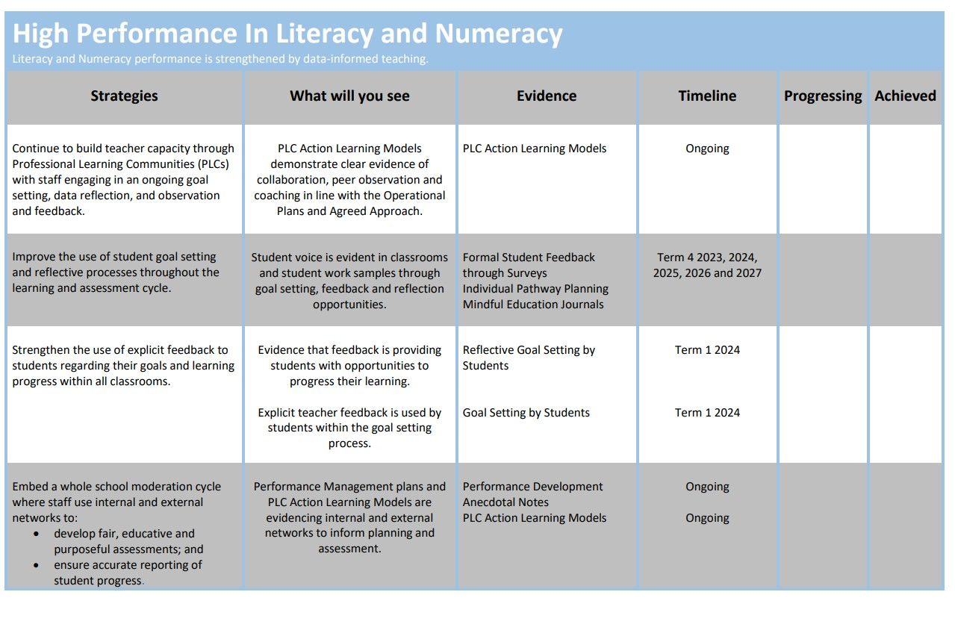

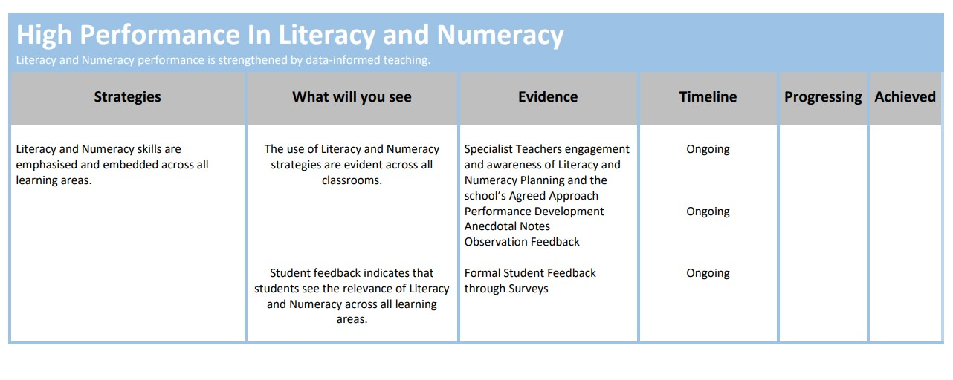

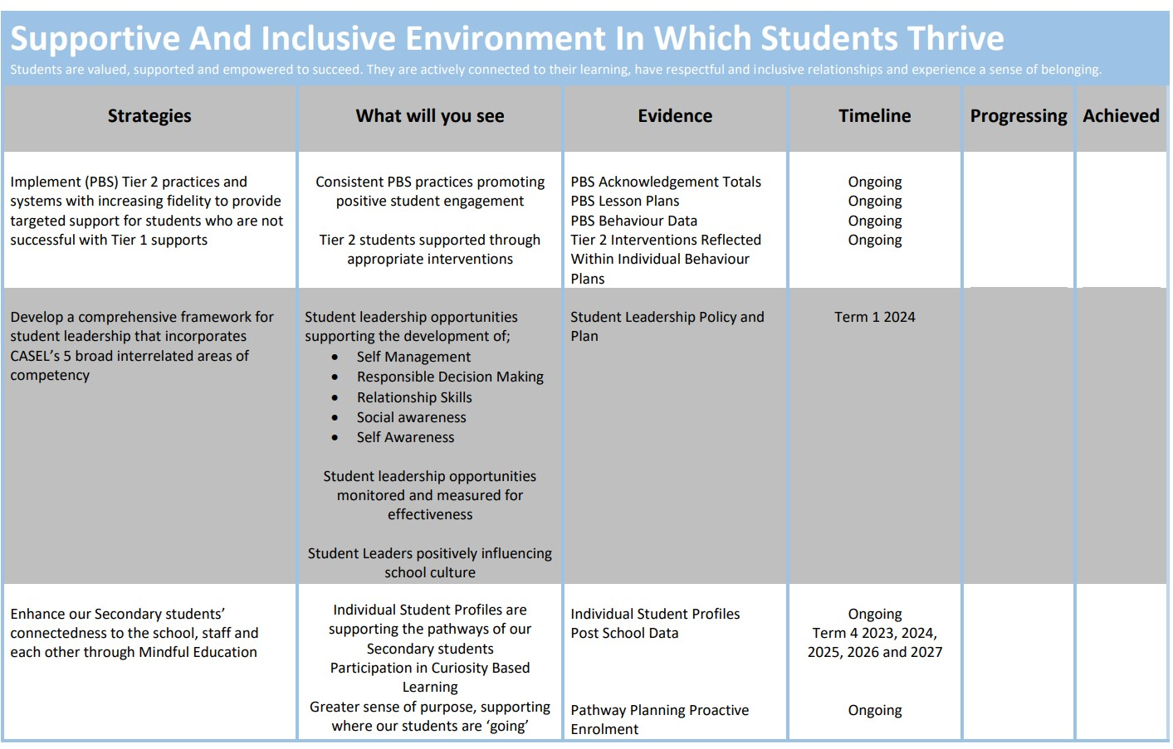
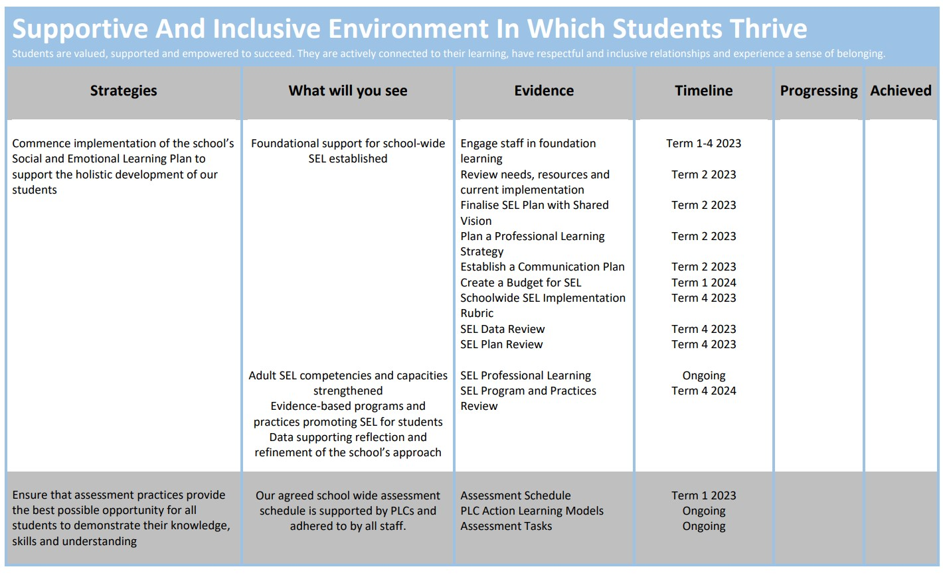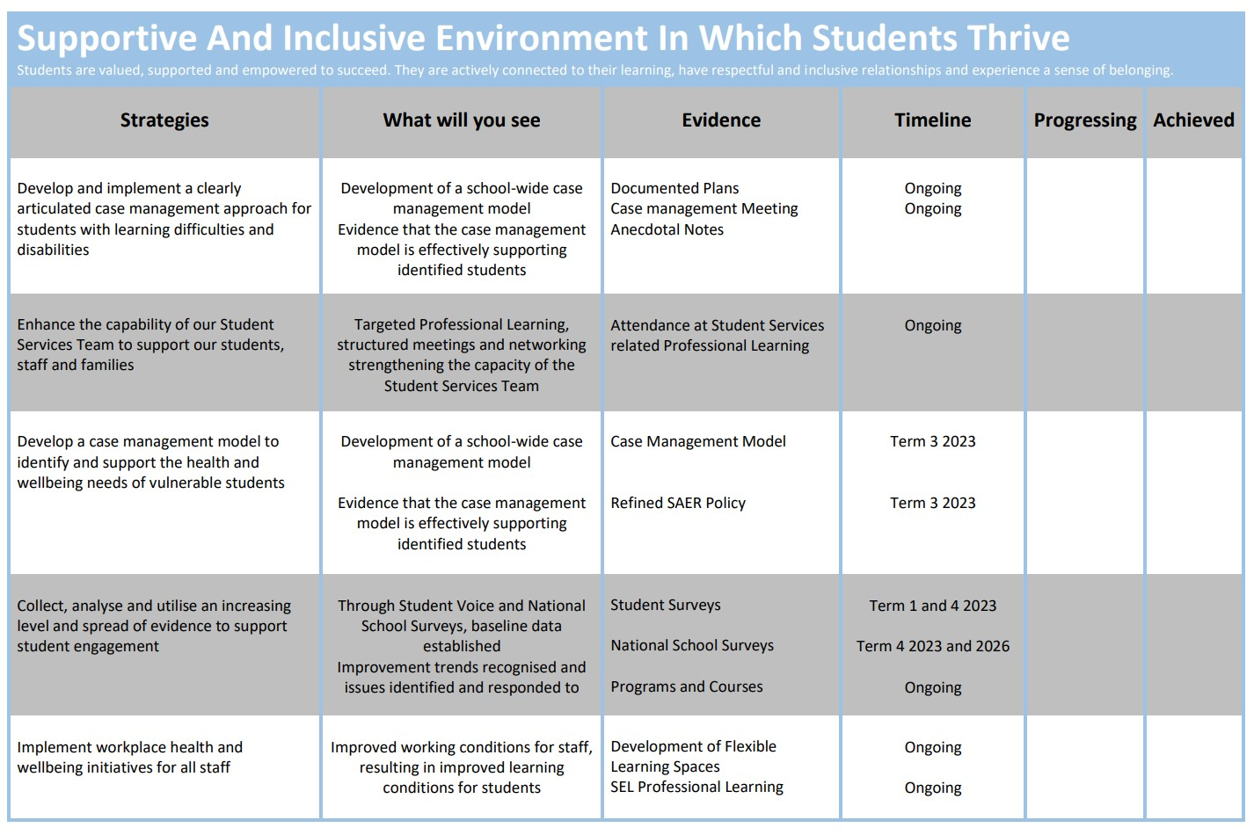

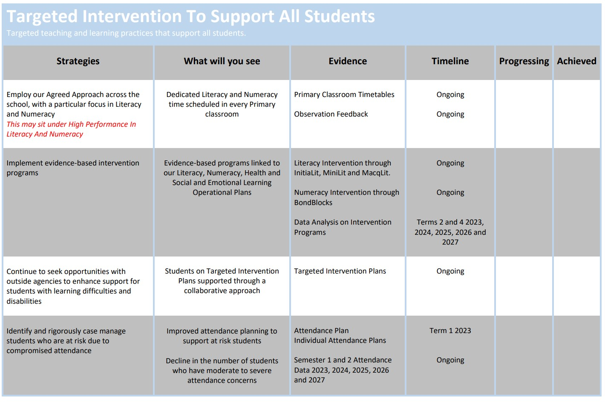

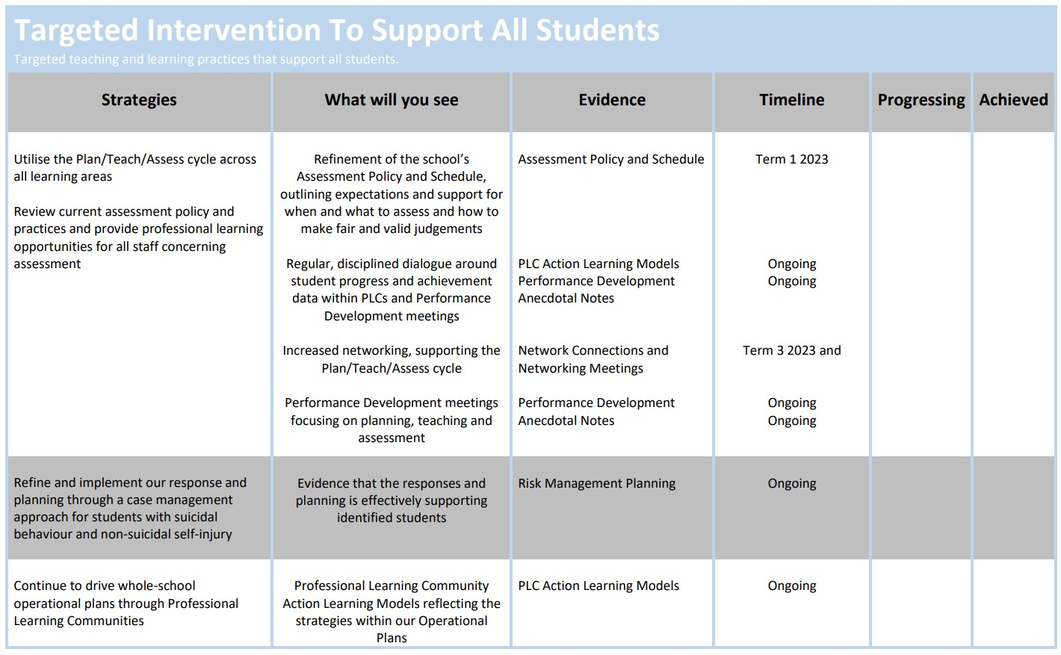

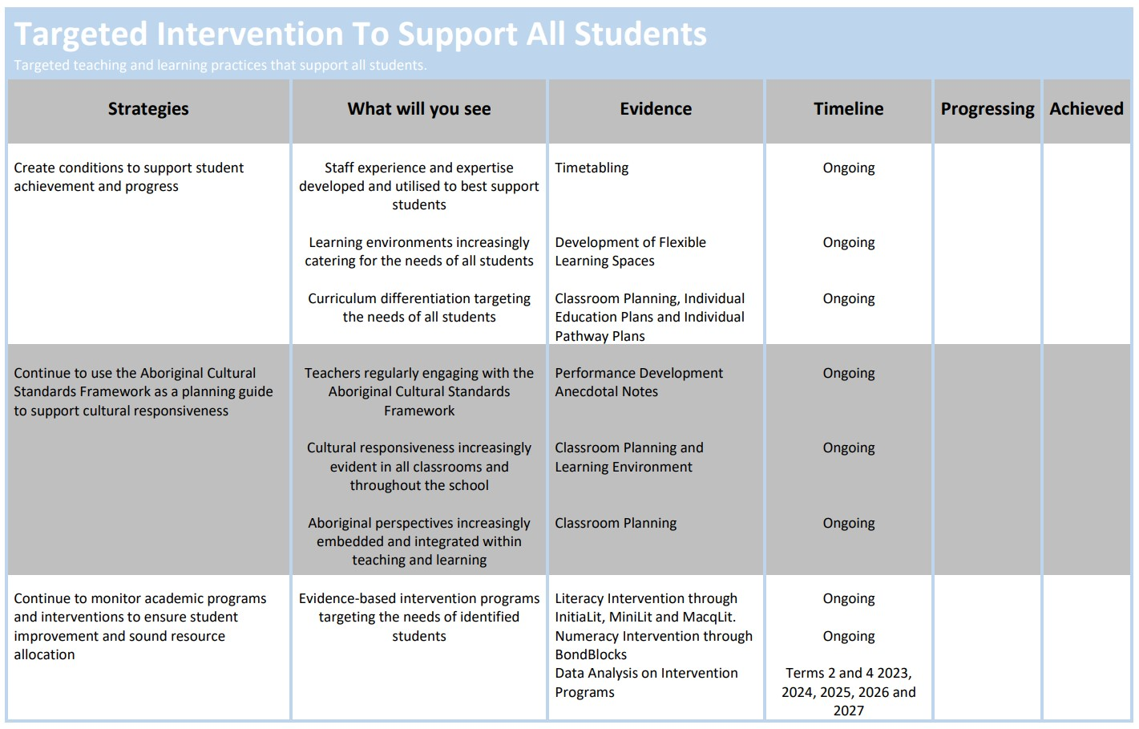

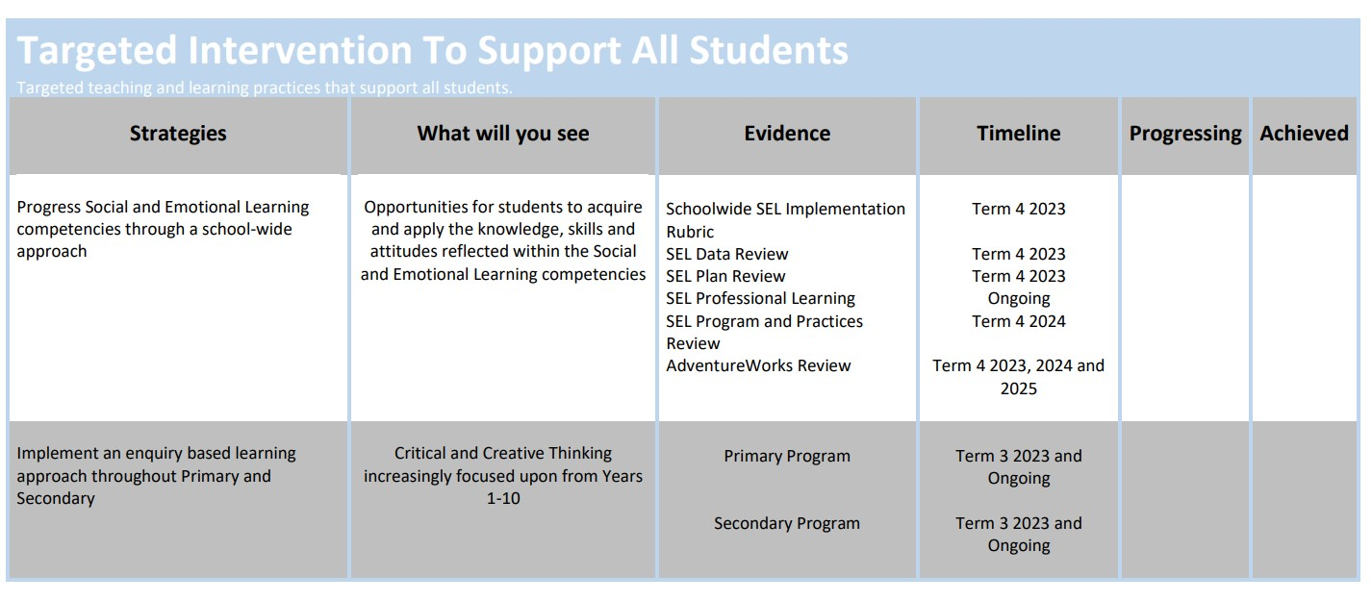

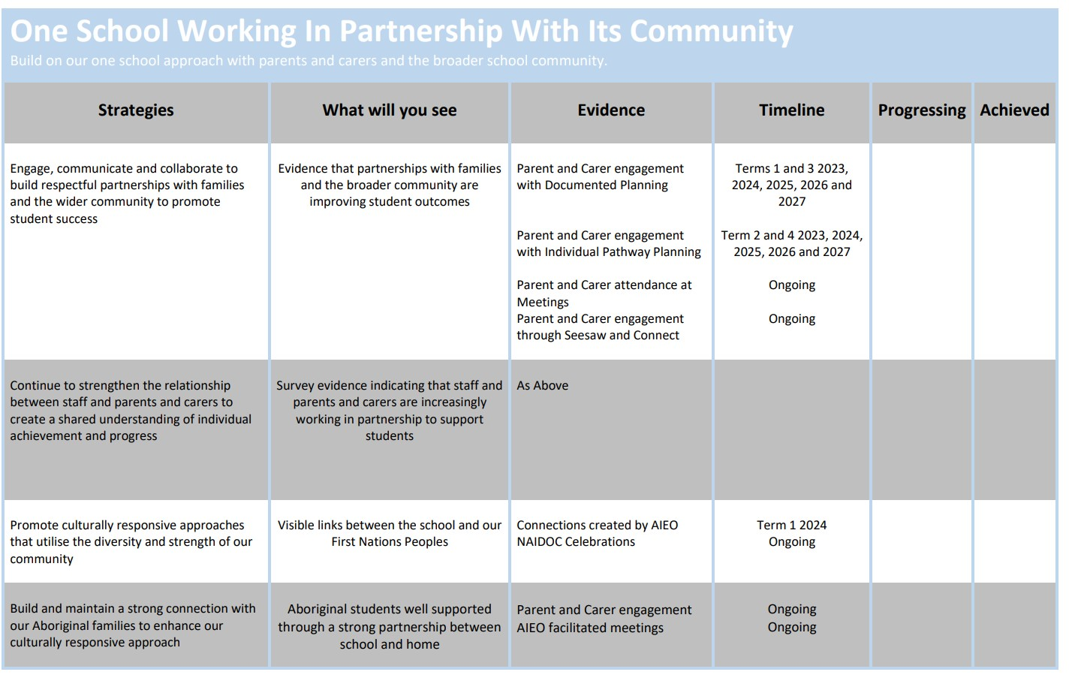
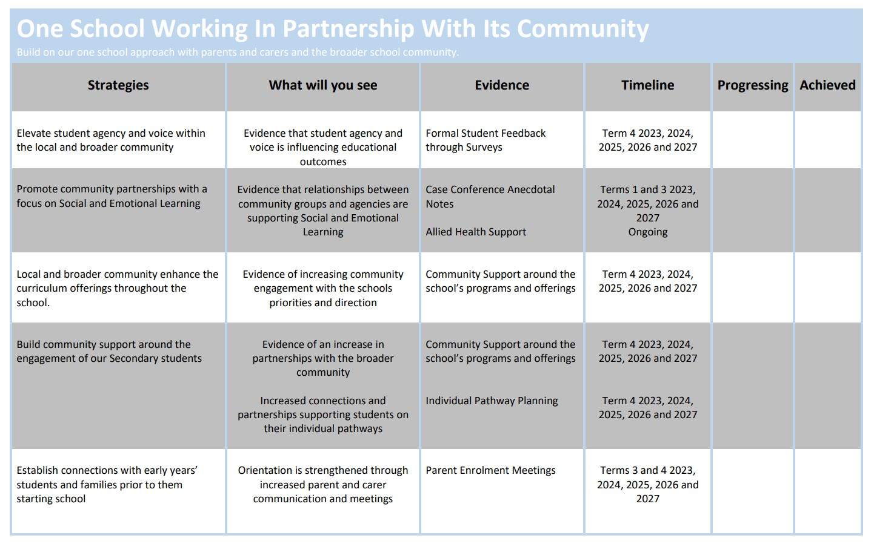

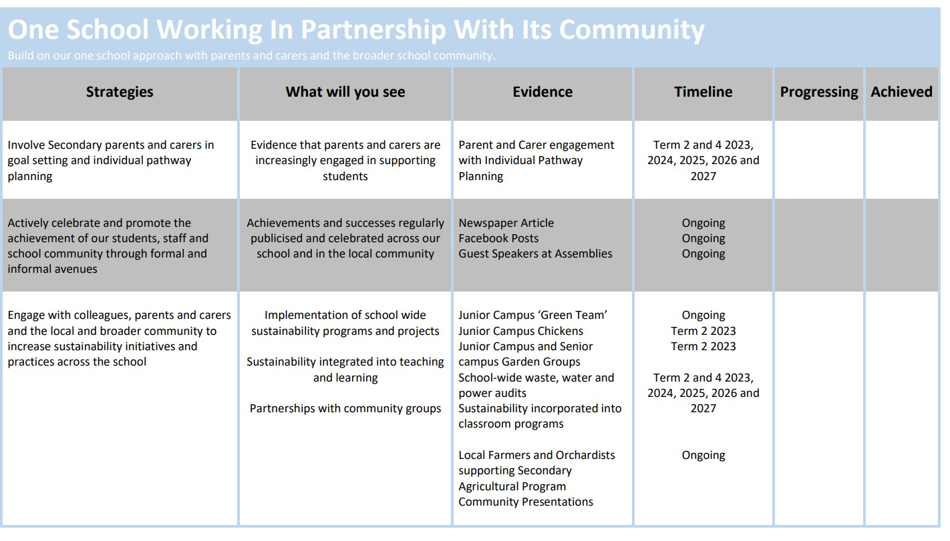

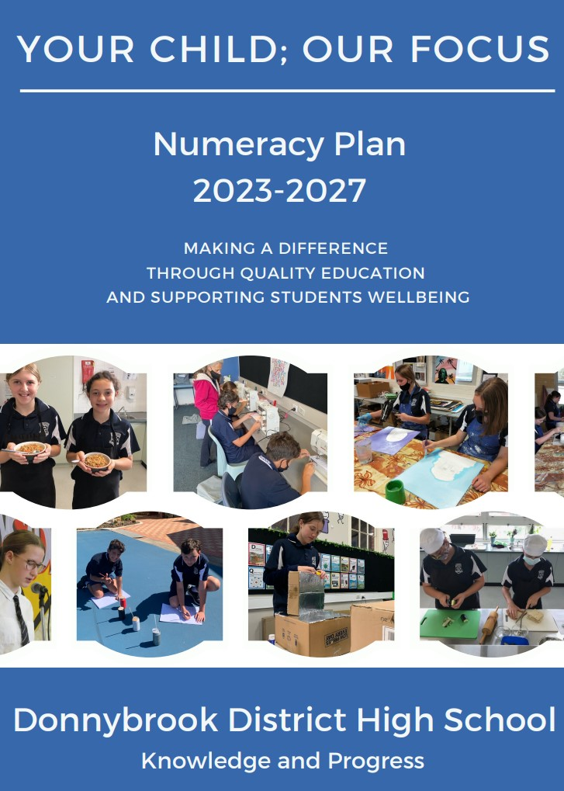

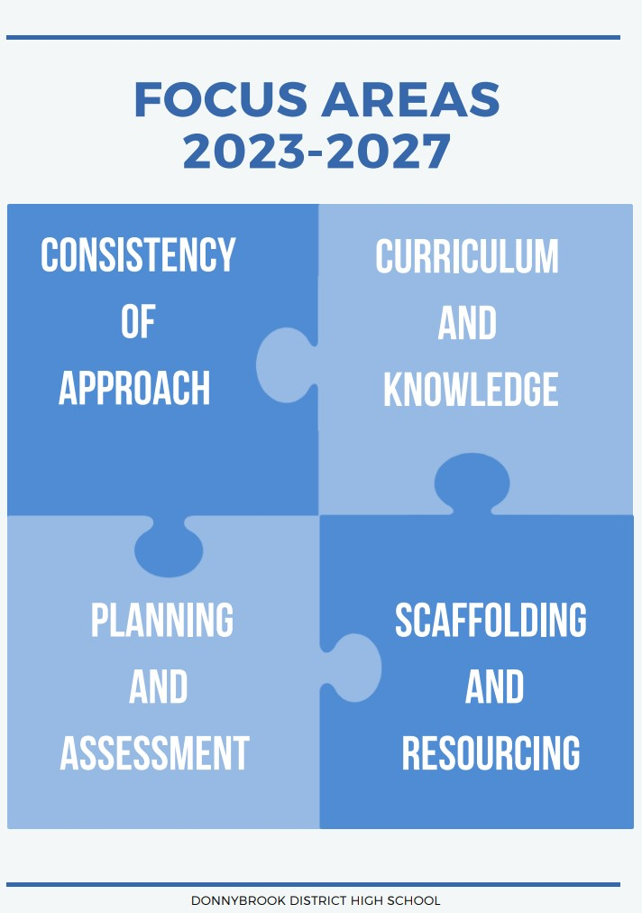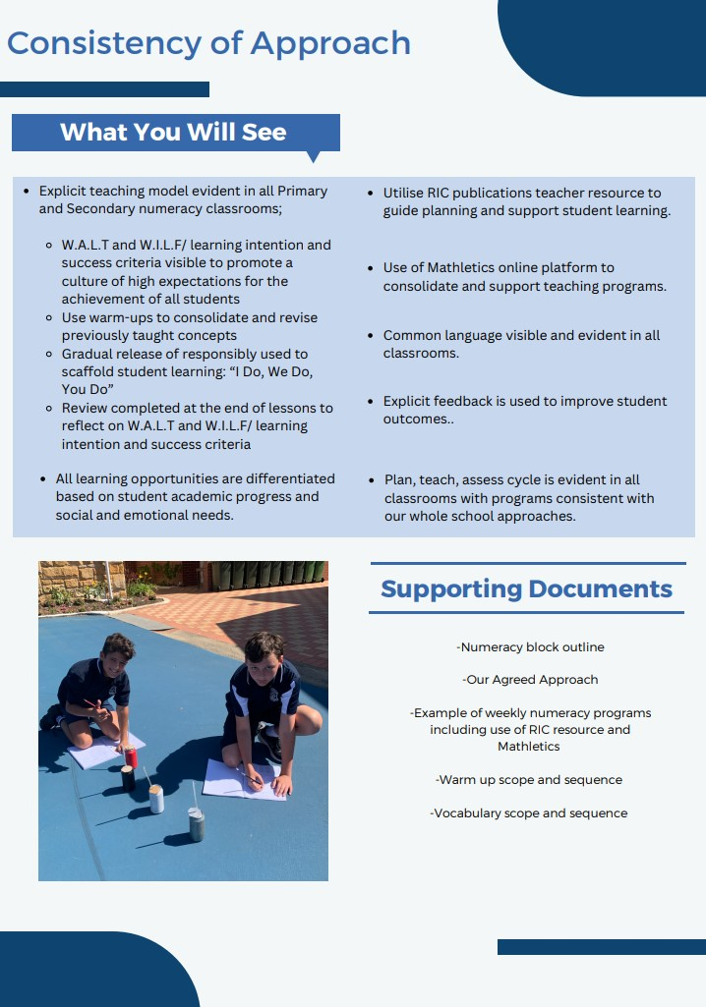

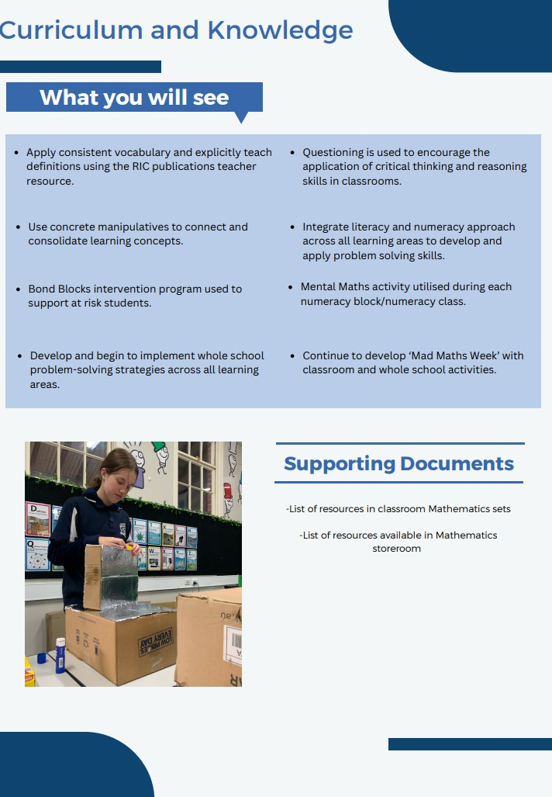

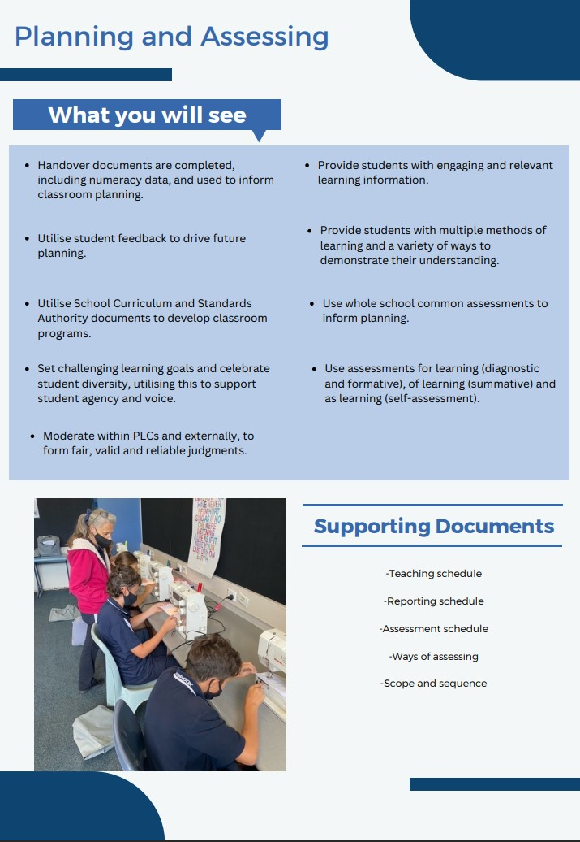

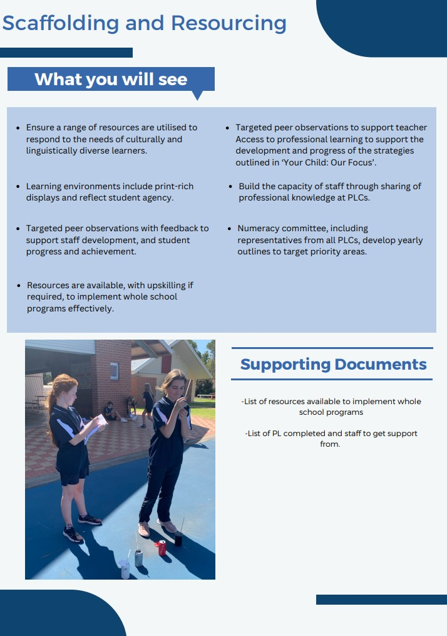

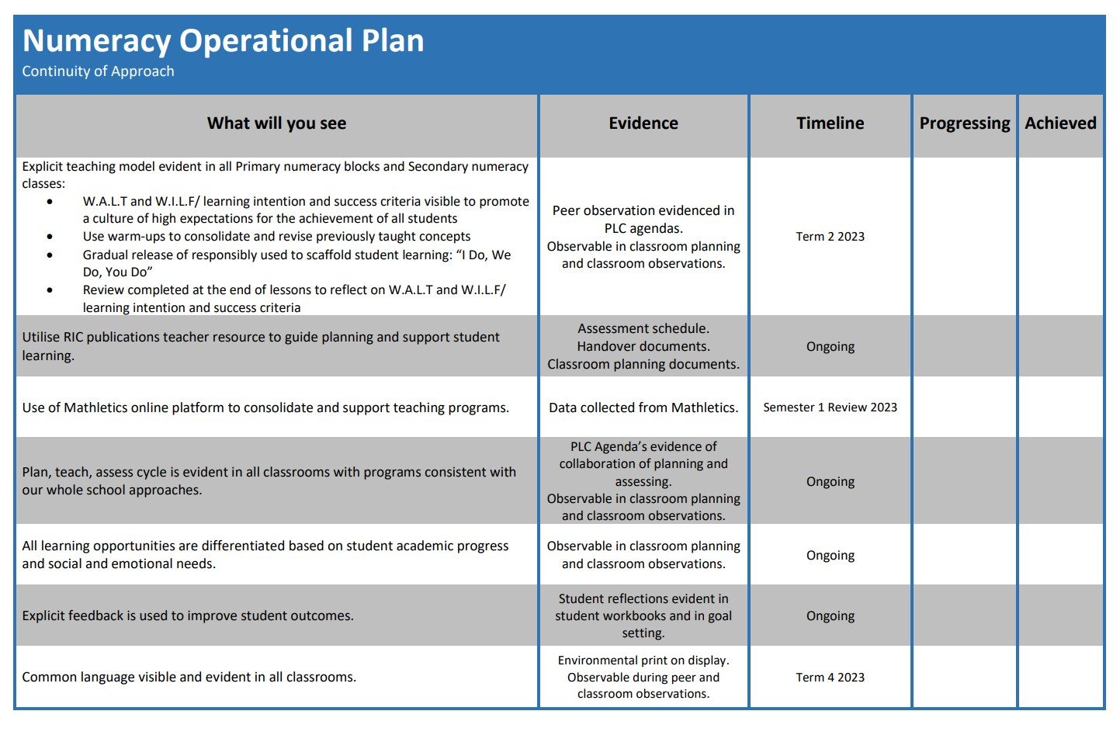

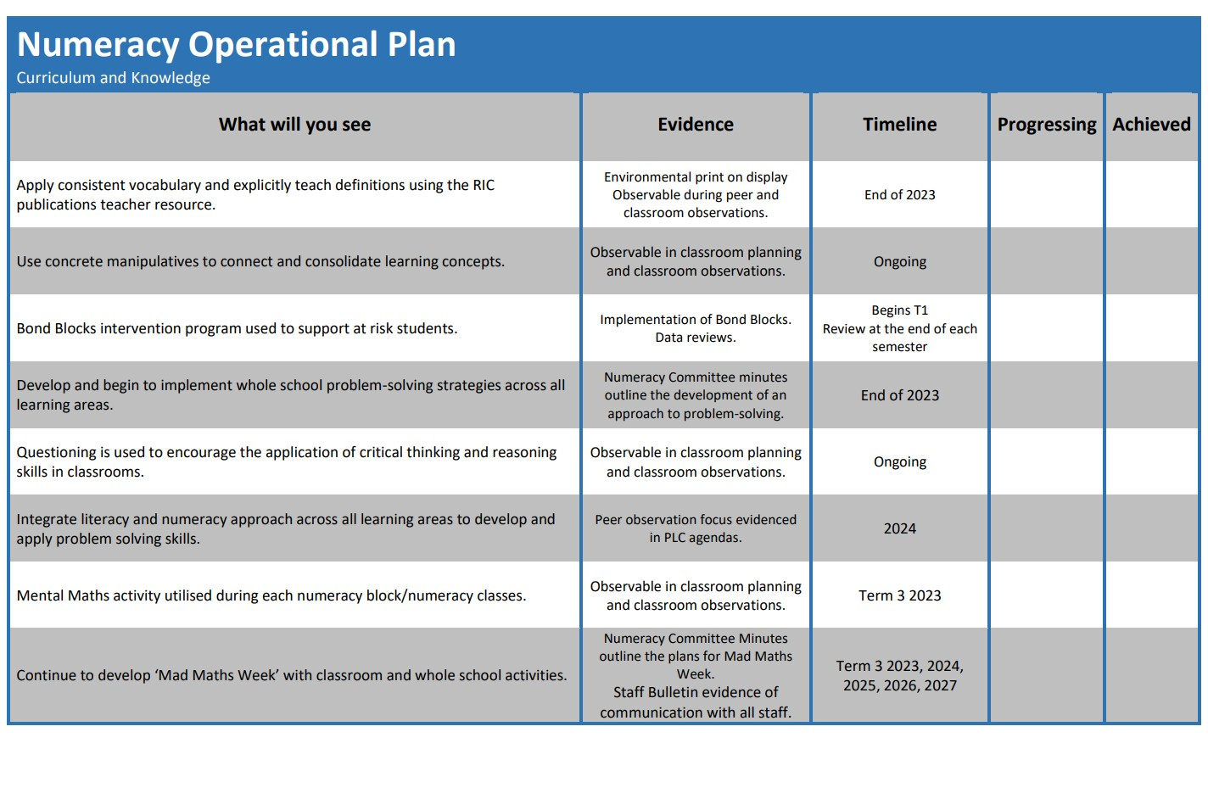
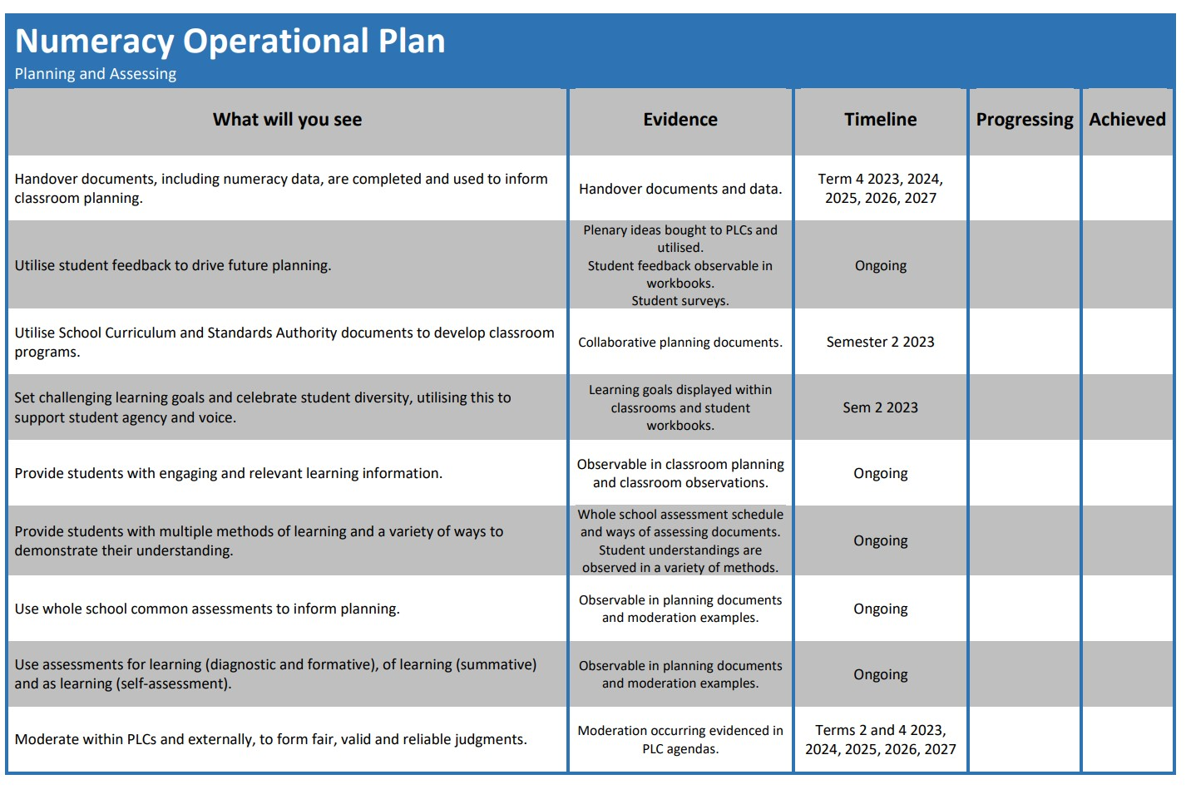
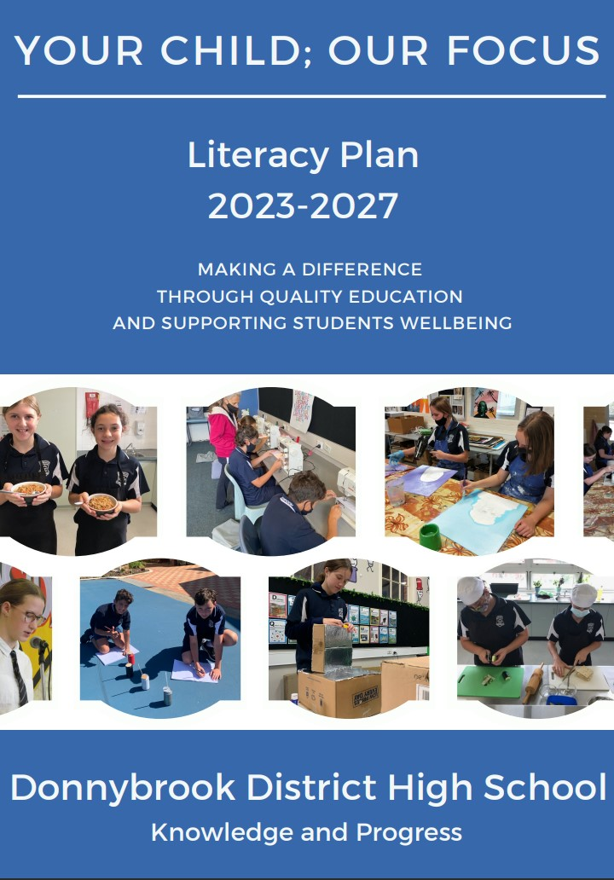
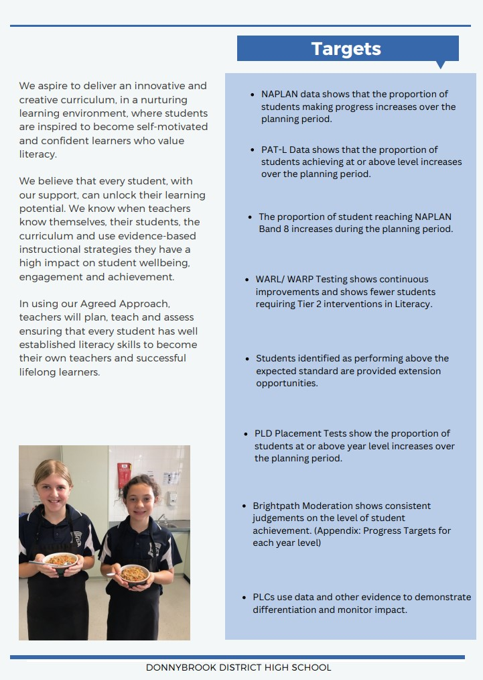
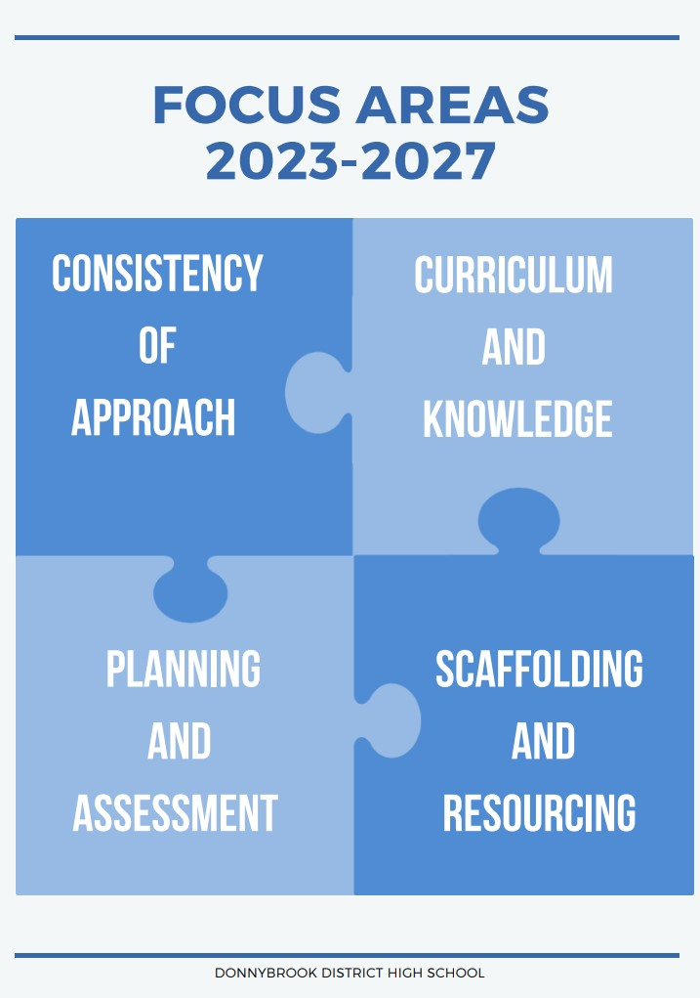
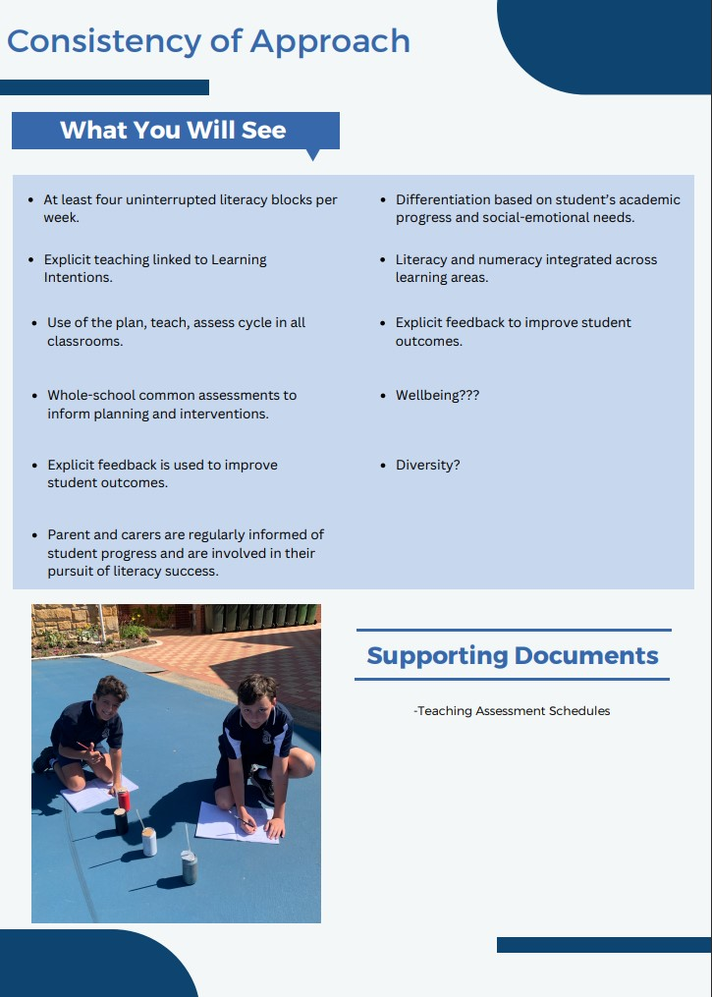
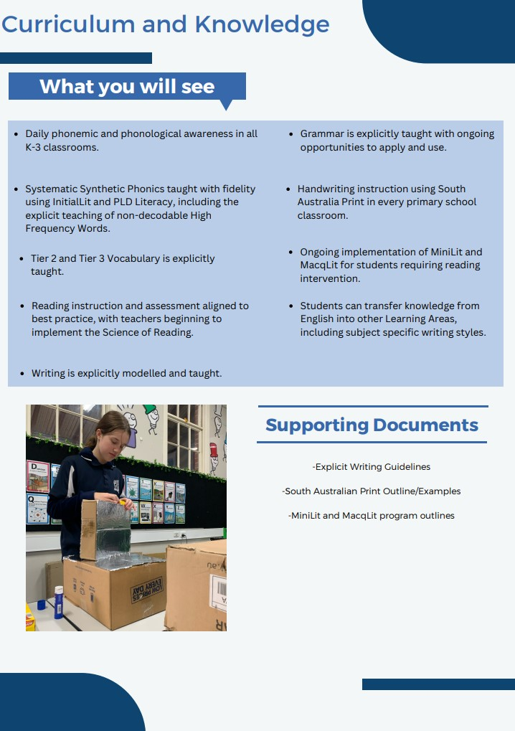
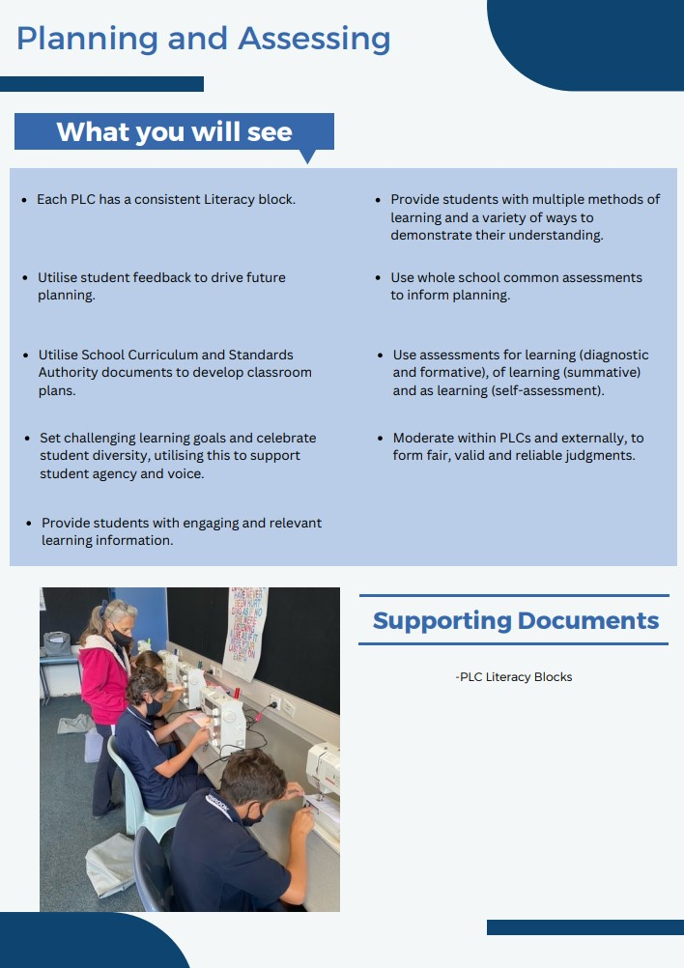
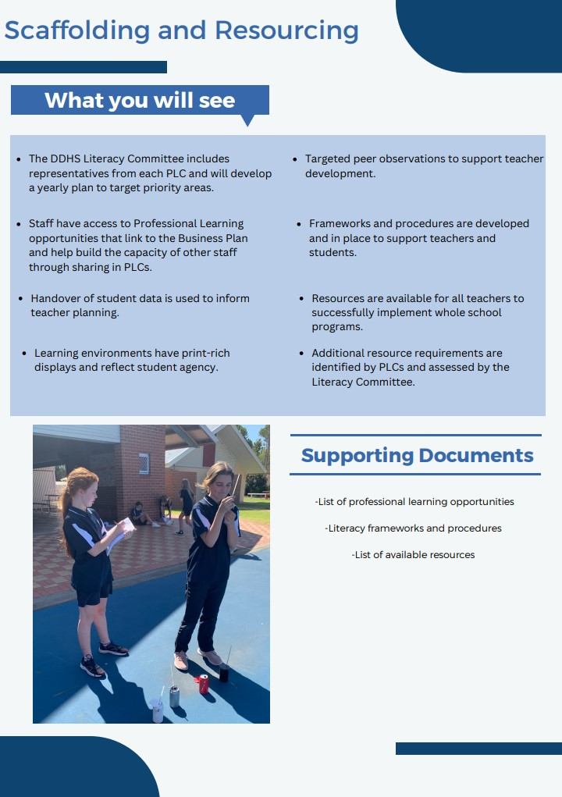
DRAFT - 2023 BOARD CALENDAR

TERM 1
Week 4, Thursday 23 February
- Salary & Cash Budget for the year
- Jonelle McLoughlin - Term ends February 2023
- Jess Richards - Term ends March 2023

Week 8, Thursday 23 March
- Annual Report

TERM 2
Week 3, Thursday 18 May

Week 8, Thursday 15 June

TERM 3
Week 3, Thursday 10 August

Week 8, Thursday 7 September

TERM 4
Week 4, Thursday 2 October

OTHER BUSINESS WITH NOTICE:
- Endorsement of voluntary Contributions and Charges.
- Endorsement of Personal Items lists.
- Endorsement of Professional Development Days

Week 8, Thursday 30 November

